Bank Loan Query Document

# Bank loan report summary

## KPI s

### Total loan applications

SELECT COUNT(ID) AS TOTAL_LOAN_APPLICATIONS

FROM BANK_LOAN_DATA;

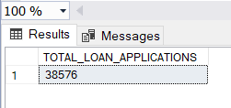

### MTD total loan applications

SELECT COUNT(ID) AS MTD_TOTAL_APPLICATIONS

FROM BANK_LOAN_DATA

WHERE MONTH(ISSUE_DATE) = 12;

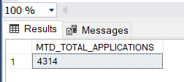

### PMTD Total loan applications

SELECT COUNT(ID) AS PMTD_TOTAL_APPLICATIONS

FROM BANK_LOAN_DATA

WHERE MONTH(ISSUE_DATE) = 11;

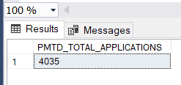

### Total loan funded

SELECT SUM(LOAN_AMOUNT) AS TOTAL_FUNDED_AMOUNT

FROM BANK_LOAN_DATA;

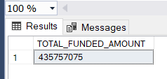

### MTD Total Funded Amount

SELECT SUM(LOAN_AMOUNT) AS MTD_TOTAL_FUNDED_AMOUNT

FROM BANK_LOAN_DATA

WHERE MONTH(ISSUE_DATE) = 12;

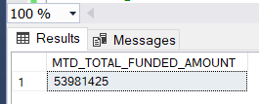

### PMTD Total Funded Amount

SELECT SUM(LOAN_AMOUNT) AS MTD_TOTAL_FUNDED_AMOUNT

FROM BANK_LOAN_DATA

WHERE MONTH(ISSUE_DATE) = 11;

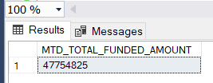

### Total Amount Received

SELECT SUM(TOTAL_PAYMENT) AS TOTAL_AMOUNT_RECEIVED

FROM BANK_LOAN_DATA

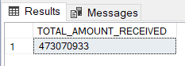

### MTD Total Amount Received

SELECT SUM(TOTAL_PAYMENT) AS MTD_TOTAL_AMOUNT_RECEIVED

FROM BANK_LOAN_DATA

WHERE MONTH(ISSUE_DATE) = 12;

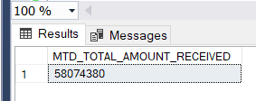

### PMTD Total Amount Received

SELECT SUM(TOTAL_PAYMENT) AS PMTD_TOTAL_AMOUNT_RECEIVED

FROM BANK_LOAN_DATA

WHERE MONTH(ISSUE_DATE) = 11;

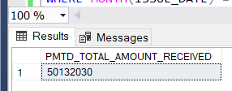

### Average Interest Rate

SELECT ROUND(AVG(INT_RATE),4)*100 AS AVERAGE_INTEREST_RATE

FROM BANK_LOAN_DATA;

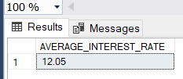

### MTD Average Interest

SELECT ROUND(AVG(INT_RATE),4)*100 AS MTD_AVERAGE_INTEREST_RATE

FROM BANK_LOAN_DATA

WHERE MONTH(ISSUE_DATE) = 12 AND YEAR(ISSUE_DATE) = 2021

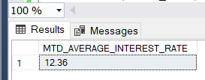

### PMTD Average Interest

SELECT ROUND(AVG(INT_RATE),4)*100 AS PMTD_AVERAGE_INTEREST_RATE

FROM BANK_LOAN_DATA

WHERE MONTH(ISSUE_DATE) = 11 AND YEAR(ISSUE_DATE) = 2021

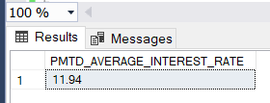

### Avg DTI

SELECT ROUND(AVG(DTI),4)*100 AS AVERAGE_DTI

FROM BANK_LOAN_DATA;

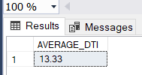

### MTD Avg DTI

SELECT ROUND(AVG(DTI),4)*100 AS MTD_AVERAGE_DTI

FROM BANK_LOAN_DATA

WHERE MONTH(ISSUE_DATE) =12 AND YEAR(ISSUE_DATE) = 2021

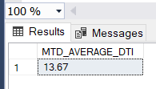

### PMTD Avg DTI

SELECT ROUND(AVG(DTI),4)*100 AS MTD_AVERAGE_DTI

FROM BANK_LOAN_DATA

WHERE MONTH(ISSUE_DATE) =11 AND YEAR(ISSUE_DATE) = 2021

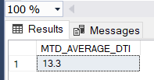

## Bank Loan Report Overview

### Good loan percentage

SELECT

((COUNT(CASE WHEN LOAN_STATUS = 'Fully Paid' OR LOAN_STATUS = 'Current' THEN id END) * 100)

/

COUNT(ID)) AS GOOD_LOAN_PERCENTAGE

FROM BANK_LOAN_DATA;

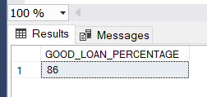

### Number of Good loan Application

SELECT COUNT(ID) AS NO_OF_GOOD_LOAN_APPLICATIONS

FROM BANK_LOAN_DATA

WHERE LOAN_STATUS = 'Fully Paid' OR LOAN_STATUS ='Current'

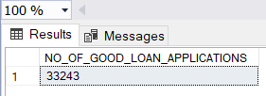

### Good Loan funded Amount

SELECT * FROM Bank_loan_data

SELECT SUM(LOAN_AMOUNT)

BANK_LOAN_DATA

WHERE LOAN_STATUS = 'Fully Paid' OR LOAN_STATUS ='Current';

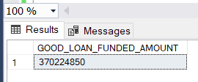

### Good Loan Total received Amount

SELECT SUM(TOTAL_PAYMENT)

FROM BANK_LOAN_DATA

WHERE LOAN_STATUS = 'Fully Paid' OR LOAN_STATUS ='Current';

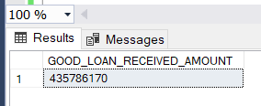

### Bad Loan Application Percentage

SELECT

((COUNT(CASE WHEN LOAN_STATUS = 'Charged off' THEN id END) * 100.0)

/

COUNT(ID)) AS BAD_LOAN_PERCENTAGE

FROM BANK_LOAN_DATA;

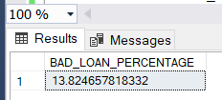

### Number of Bad Loan Applications

SELECT COUNT(ID)

FROM BANK_LOAN_DATA

WHERE LOAN_STATUS = 'Charged off';

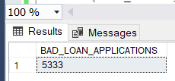

### Bad Loan Funded Amount

SELECT SUM(LOAN_AMOUNT)

FROM BANK_LOAN_DATA

WHERE LOAN_STATUS = 'Charged off';

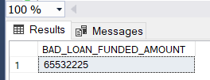

### Bad Loan Total Received Amount

SELECT SUM(TOTAL_PAYMENT)

FROM BANK_LOAN_DATA

WHERE LOAN_STATUS = 'Charged off';

Loan Status

SELECT LOAN_STATUS,

COUNT(ID) AS LOAN_COUNT,

SUM(LOAN_AMOUNT) AS TOTAL_FUNDED_AMOUNT,

SUM(TOTAL_PAYMENT) AS TOTAL_AMOUNT_RECEIVED,

AVG(INT_RATE * 100) AS INTEREST_RATE,

AVG(DTI *100) AS DTI

FROM BANK_LOAN_DATA

GROUP BY LOAN_STATUS

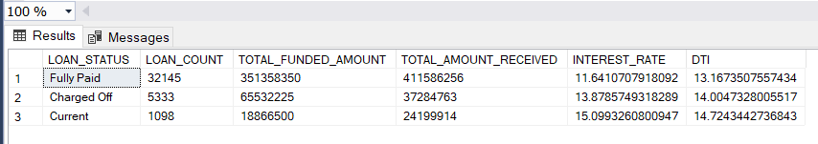

SELECT LOAN_STATUS,

SUM(TOTAL_PAYMENT) AS MTD_TOTAL_AMOUNT_RECEIVED,

SUM(LOAN_AMOUNT) AS MTD_TOTAL_FUNDED_AMOUNT

FROM BANK_LOAN_DATA

WHERE MONTH(ISSUE_DATE) = 12

GROUP BY LOAN_STATUS;

